The shrink threshold parameter of the NearestCentroid classifier implements the nearest shrunken centroid classifier. In effect, the value of each feature for each centroid is divided by the feature's within-class variance. Shrink threshold is then used to reduce the feature values. Most notably, if a specific feature value approaches zero, it is set to zero. This effectively prevents the feature from influencing the classification. This is useful for removing distracting features, for example.

In the following example, using a small shrink threshold raises the

**[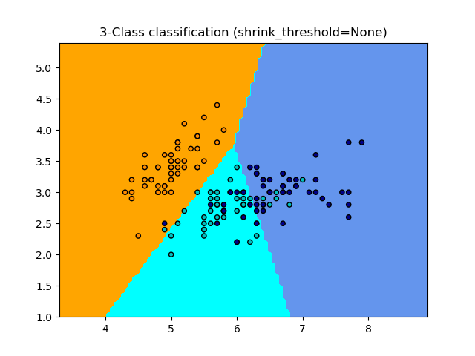](https://scikit-learn.org/stable/auto_examples/neighbors/plot_nearest_centroid.html) [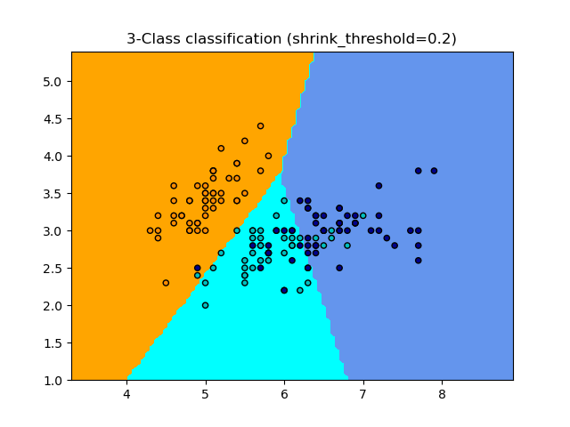](https://scikit-learn.org/stable/auto_examples/neighbors/plot_nearest_centroid.html)**